Match the function to the leaf structures.
Note: a structure may have more than one function.

a. Allows carbon dioxide to reach the photosynthetic cells
b. Helps to control water loss
c. Maximizes external surface area of the blade for light interception
d. Maximizes internal surface area of the leaf for light interception
e. Photosynthesis
f. Transportation

_______ Thin flat surface of blade

_______ Cuticle

_______ Palisade cells of mesophyll

_______ Spongy cells of mesophyll

_______ Air spaces

_______ Veins

_______ Stomata

_______ Guard cells
Label the root tip diagram.

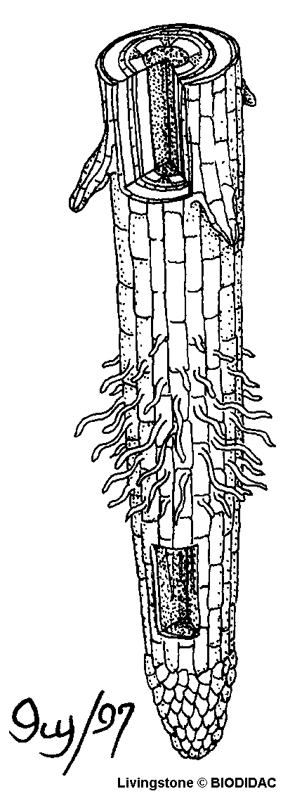
Lateral root
1
2
3
4

1. ___________________________

2. ___________________________

3. ___________________________

4. ___________________________

